**Java 2D Graphics Assignment**

**Description**: Java program that creates a window and draws PacMan and Friends graphics using simple Java 2D shapes. Program includes 12 shapes of the following types: Circles, Ellipses, Rectangles, Lines, and Polygons.

Below is a screenshot of the graphics created when the program is launched:

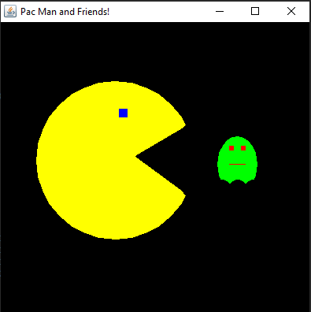

**Student**: Patrick Walsh

**School**: University of Maryland Global Campus

**Course**: CMSC 325 6380

**Date**: 8/20/2021

**Professor**: Dr. Michael Elms